Documentation for electronics project

( soil watering system)

1. Asser ayman
2. Abdelrhman baher
3. Fatma Nasser
4. Rana Hesham
5. Habiba Alaa

Problem definition :

During summers, most people are too lazy to water the potted plants on their rooftop gardens every day. Explained in this section is a simple and exciting automatic plant watering system that you can build yourself in just a few hours. It is an Arduino based automatic plant watering system that uses a soil moisture sensor.

In the plant watering system, soil moisture sensor checks the moisture level in the soil and provide it with water if it needs.

Description:

This project uses Arduino board, It is programmed in such a way that it will sense the moisture level of the plants and supply the water if required. This type of system is often used for general plant care, as part of caring for small and large gardens. Normally, the plants need to be watered twice daily, morning and evening. So, the microcontroller has to be coded to water the plants in the greenhouse about two times per day. People enjoy plants, their benefits and the feeling related to nurturing them. However for most people it becomes challenging to keep them healthy and alive. To accommodate this challenge we have developed a prototype, which makes a plant more self-sufficient, watering itself from a large water tank .The system automation is designed to be assistive to the user. We hope that through this prototype people will enjoy having plants without the challenges related to absent or forgetfulness.

Components:

1. Sensor:

Each flowerpot need such a soil moisture sensor to collect the humility data. This Soil Moisture Sensor can be used to detect the moisture of soil or judge if there is water around the sensor, let the plants in your garden reach out for human help.Insert this module into the soil and then adjust the on-board potentiometer adjust the sensitivity. The sensor would outputs logic HIGH/LOW when the moisture is higher/lower than the threshold set by the potentiometer.

1. Arduino:

The Arduino Uno is a microcontroller board . It has 14 digital input/output pins (of which 6 can be used as PWM outputs), 6 analog inputs, a 16 MHz ceramic resonator, a USB connection, a power jack, an ICSP header, and a reset button. It contains everything needed to support the microcontroller; simply connect it to a computer with a USB cable or power it with a AC-to-DC adapter or battery to get started.

c)Adapter:

This is a high quality AC/DC adapter, it has over hot protection and short circuit protection .It is light and easy to carry while traveling. The input voltage range from AC110V to AC240V, makes this module can be used around the world.

d)Small pump:

The water pump is used to artificially supply water for a particular task. It can be electronically controlled by interfacing it to a microcontroller. It can be triggered ON/OFF by sending signals as required. The process of artificially supplying water is known as pumping. There are many varieties of water pumps used.

e)Relay:

A Relay is actually a switch which is electrically operated by an electromagnet. The electromagnet is activated with a low voltage, for example 5 volts from a microcontroller and it pulls a contact to make or break a high voltage circuit.

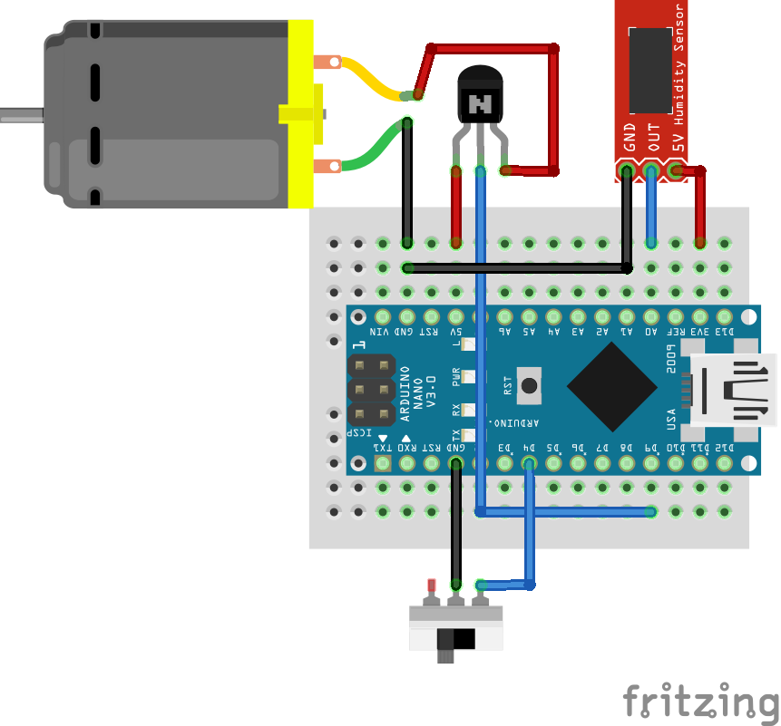

1. Connect the Arduino to your computer.

2. Download the attached code and open it.

3. Select your COM Port and your Arduino Board from Tools Option.

4. Click Upload Button

5. connect the moisture sensor to the Arduino .

a)Connect the VCC node to 3 volts node in the Arduino board by wires.

b)conncet the GND(ground) node to G node Arduino board by wires.

c)connect the DO node to 8 node in the Arduino board by wires.

6. connect the Relay to the Arduino .

a) connect the V node with 5 volts node in Arduino board .

b) connect the CI node to 13 node in Arduino board .

c) connect G node to G node of Arduino board.

7. Connect the Arduino to power supply (5V) via USB or External power source.

8. Dip or bury the moisture sensor in the soil. Better place the sensor near the roots of plants for accurate measurements. Do not short the terminals.

9. Connect the Water pump to the Relay (N/O and Common terminals) and switch ON the mains. Refer the Circuit for connection details and pin out.

The Arduino reads the status of the soil using Soil Moisture Sensor. If the Soil is DRY it does the following Operations....

1) Checks for the availability of water using water level sensor.

2) If the water is available, the Pump is turned ON and is automatically turned OFF when sufficient amount of water is supplied. The Pump is Driven by a Relay driver circuit.

Reference:

[https://youtu.be/nUHizmtyt74](https://l.facebook.com/l.php?u=https%3A%2F%2Fyoutu.be%2FnUHizmtyt74&h=ATNaHCmhlcc3YDp7MjT3LwtoA6jmTngznJmbwpkvfvOy8RECIXXO3kDB1_zFMhzVVto_607jQbliob_JvhX2CY3pQ2j9OxqhEw3T_ZzWfFkLcrp5iCcOoQ)

Test cases:

1. If the soil is dry the sensor will notify the pump to start to watering the soil.
2. If the soil already has moisture ..There is no watering.